April 2019 Flyer
April is a busy month for all of us at Fanny Bay Salmonid Enhancement Society world headquarters on Berray Road and at the Wilfred Creek hatchery. Not only for all the routine work that always needs doing and gets done, but for the events that make it a key part of the year. April is when—drum roll here, please—our three smolt counting fences go into action, thousands and thousands of chum and coho alevins are moved into holding tanks, more thousands of salvaged wild salmon go back out into their home creeks, and all the advance planning and organizing for the River Never Sleeps Festival happens. All of these events take place only because of the dedication combined with muscle power and smart thinking that is such a normal part of our daily success story here on the banks of the mighty Rosewall, something all of you on Ships Point can appreciate because we’re here for you, and the salmon. Don’t thank us, we’d do all this wonderful stuff even if no one noticed, because we’re all so modest and unassuming. (That’s the theme music from Titanic you hear.)
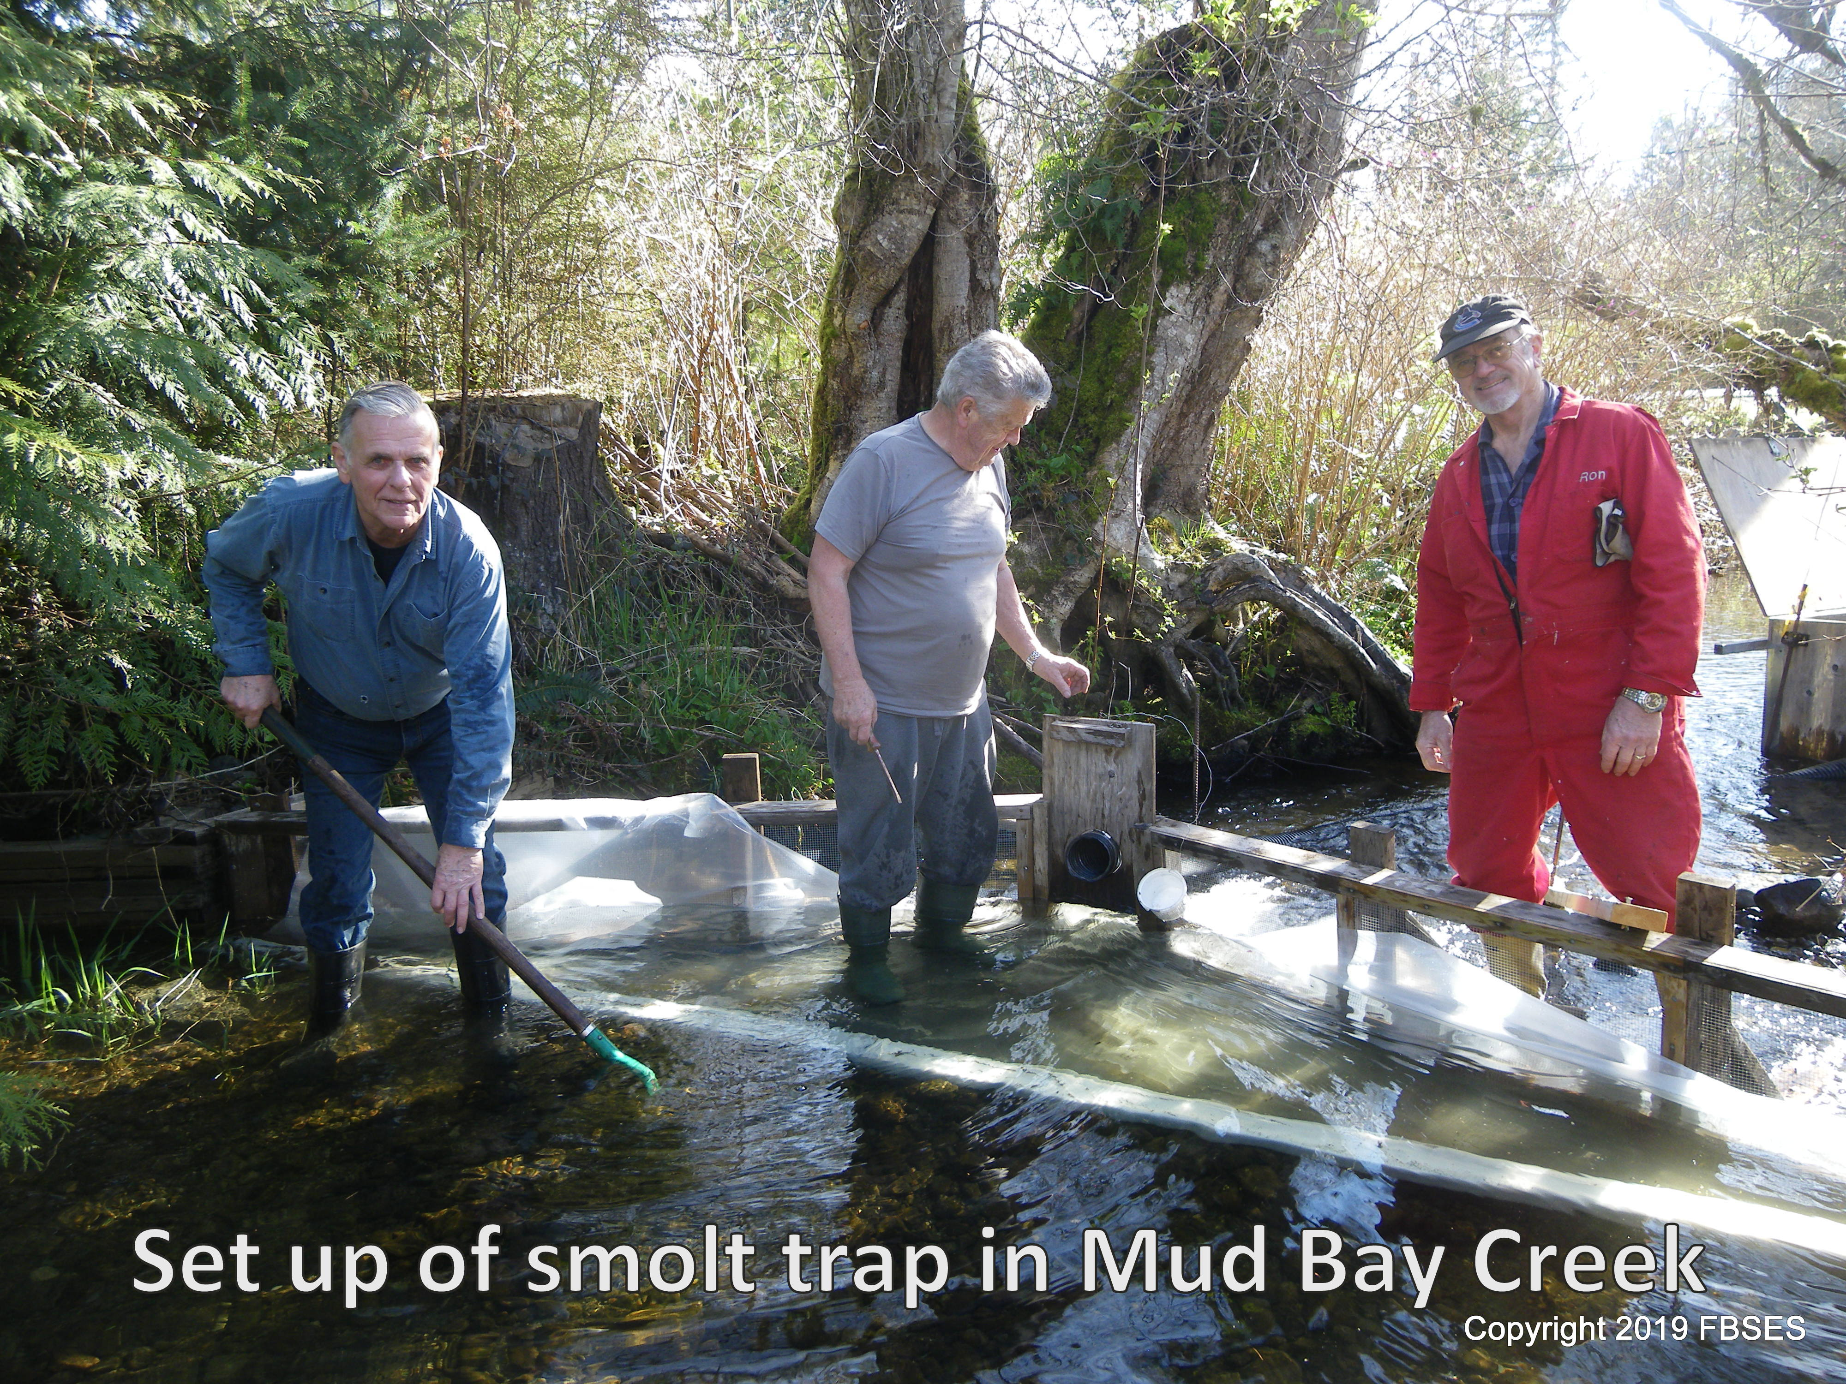
Our three fences started as one, on Waterloo Creek, which was moved to Mud Bay Creek for good reasons, and then another was added on Cook Creek, and the third at Wilfred. Each gets visited every day during counting season and all the wild things collected in a holding box are enumerated, cataloged and recorded, then released to go on their way. FBS volunteers do all this in addition to their regular attendance at work party days and chores like feeding, moving, counting, weighing, hovering and helicopter parenting thousands of brood stock and salvage fish. This year will be the start of something else new and different, because we’re always up for that sort of thing. Previous years have seen us rescue wild salmon fry from drying creeks in warm weather, and release them in fall. This year we will be sending out rescued wild fish after an extra year of holding and feeding in an attempt to improve their chances of survival. Those chances are small enough, but we do extra work like this because not only are we smart and strong, we care. (Some soaring choral background music would be nice here) Also new and different every year is our annual open house, the River Never Sleeps, on May 5, 2019, because even though this is its 10th straight year, we invent it from the ground up every time. And we do it for you, in case I haven’t mentioned that lately. We have live music at the event, and depending where you are, at the face or fish painting, trying fly casting or meeting an owl, it can either be background or in your face. Free admission, goodie bags, family friendly concession pricing, oysters from Macs, it gets better every year. Other great things we’ve been doing recently are hosting two separate enhancement related events; a workshop for people learning how to prevent stream bank erosion, and a Project Watershed planning session for environmental efforts on our coastline. And we’re here for you every Wednesday and Saturday mornings, and we are informative, but modest, of course, on www.fbses.ca

